The New Age Interactive Soccer Training System: A Novel Approach of collaborative learning outside the classroom

Arnold Lee
College of Education
University of Illinois at Chicago
1040 W. Harrison St.
Chicago, IL 60607
USA
alee29@uic.edu

ABSTRACT
A complete learning experience of a child includes not only academic but also physical activities. Often times, interpersonal relationship and conflicts are often made outside the wall of a classroom. In this paper, we aim to bring collaborative learning outside the classroom and into a soccer field through a hypothetical system for children age 5-14 that will promote teamwork and betterment of interpersonal communication on and off the field. This system consist of three sections: An input system that reads the position and direction of both the ball and the players; A software component that calculates the best move given the input, and an output system that utilize the Bluetooth protocol to transmit the best move to the players. This paper will focus on the software part of the system, while also briefly sketch the schematics and requirement of the entire system, including its specification and potential cost.
Categories and Subject Descriptors
H.5.2 [Information Interfaces and Presentation] User Interfaces - Input devices and strategies, Interaction styles
H.5.1 [Information Interfaces and Presentation] Multimedia Information Systems – Audio input / Output
K.3.1 [Computer and Education] Computing Uses in Education- Collaborative Learning
General Terms
Algorithms, Documentation, Design, Experimentation, Human Factors, Verification
Keywords
Soccer, children, NAISTS, interactive communication, obesity, selfish, GPS, camera, optical sensor, Bluetooth, collaborative learning, text to speech

INTRODUCTION
Child development experts note that children become interested in team sports around ages 5-6 [1]. Some early childhood educators feel that if children learn the importance of cooperating with their peers at a young age, they will be more socially ready for kindergarten and grade school [2]. Team sports are also useful for teaching youth many important skills. The first of these skills is competition. In today's world, we are surrounded by competition. Adults face competition when they are applying for and keeping
jobs, whereas children face competition in academics and sports. Participating in competitive team sports at an early age gives children an opportunity to understand the healthy aspects of competition in a friendly environment. Students of all ages who participate in sports have been found to cope better with competition in other areas of their life [3]. Still, highly competitive activity at young ages (5-7 years)—for example, being part of teams that travel to competitions—may expose children to unhealthy values. Thus, emphasis needs to be placed on cooperation over competition in team sports, especially with young children.

Permission to make digital or hard copies of all or part of this work for personal or classroom use is granted without fee provided that copies are not made or distributed for profit or commercial advantage and that copies bear this notice and the full citation on the first page. To copy otherwise, or republish, to post on servers or to redistribute to lists, requires prior specific permission and/or a fee.

Team sports also help a child's physical well-being. Children who are actively involved in a sport are more likely to describe themselves as being in good physical health than students who do not participate in anything. [4] Over the past three decades, childhood obesity rates in America have tripled, and today, nearly one in three children in America are overweight or obese. The numbers are even higher in African American and Hispanic communities, where nearly 40% of the children are overweight or obese. If we don't solve this problem, one third of all children born in 2000 or later will suffer from diabetes at some point in their lives. Many others will face chronic obesity-related health problems like heart disease, high blood pressure, cancer, and asthma. [5]
Besides inside the wall of the classroom, being able to spend time with their friends outside of school is more important to children than knowing they are physically active. Life skill gains through social interaction can be tremendous [6]. Social interaction in team sports teaches youth to: 1) Associate with their peers; 2) Solve conflict; and 3) Communicate effectively with their peers. [6]
This paper focus a new technological platform for young children to learn the social interaction skills as mentioned in [6], as well as physical health benefits [3] on the side. We choose to use soccer (association football, or just “football” outside the U.S.) as our theme of the system as this is the most popular sport in the world, and also played among a majority of the pre-high-school youth in the U.S. [7]

BACKGROUND
Our system is dubbed The New Age Interactive Soccer Training System, referred as NAISTS hereafter. The “New Age” moniker comes from the novelty of the concept, coupled with being in calendar year 2012, which was widely believe to be the year where major scientific advancements will be made. [8].
Currently, soccer coaching are all done by human, and human are prone to mistakes. Furthermore, with the case of youth coaching, there are many situations where the coach might be the parent of one of child in the team (or some other relationships exist). This might lead to bias or favoritism. NAISTS, as an objective system, aim to reduce these kinds of bias.
One major problem that every soccer coach is facing is selfish players hogging the ball around and pretends himself/herself as the next superstar. The reason is very simple: A goal scorer gets all the glory of the moment. So there are no surprises that sometimes kids get a little selfish when the opportunity to score presents itself. Once the kids are all pumped up to get a goal, they might start forcing their way into tight defense by themselves, start forcing shots, or taking shots that they aren’t ready to take. In these circumstances, it is better just hold on to the ball and pass around and await a new opening to the goal. (This obviously does not apply if your team is trailing and time is running out). However, there are times when kids need to be selfish. Forcing players to passes may end up giving up good scoring chances. In soccer, awareness and communication are the biggest assets of having a positive attacking mentality [9]. Having communication problems can null a team’s firepower quickly. NAISTS aim to solve the issue where each player is being given constant feedback from a computer that is analyzing every move of every teammate, and give a recommendation for their move, all within near real-time.
Such phenomenon can also be found can be found in online multiplayer game as well. In 2008, a UK game developer by the name CyberSports released the world’s first massively multiplayer online role playing soccer game called Football Superstars[10]. In FS, each user is a single player and has a first-person viewpoint as if you are on the pitch. Players take on the role of up-and-coming sporting stars. Initially players start with limited football skills and little money – from here they will begin to climb the divisional ladders, form clubs with other players and improve their overall rating. A screenshot of the game is depicted in Figure 1. In the FS players forum, people are constantly complaining about how selfish players destroy their enjoyment of the game ( see [11].[12].[13]).

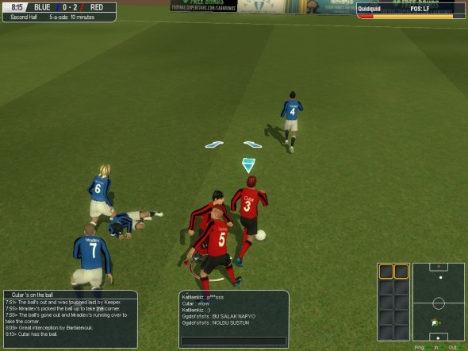
Figure 1: A screenshot from the MMO “Football Superstars”

THE SYSTEM

Overview
NAISTS consist of three portions: the input module, the processing module, and the output module. Figure 2 depicts the schematic of the system.
The input portion provides the location and direction of each player on the training team and location of the ball. To achieve that, we propose the use of camera along with GPS tracking.
The processing module consists of servers which analyze the input data and determine the best move for specific player in a specific time. The software, which will run on the servers, will have a graphic-user interface for the coach that monitors the game to make appropriate adjustments or interventions if needed.
The output module consists of Bluetooth transmitters, which will transmit speech instructions from the processing servers to player’s earpiece.

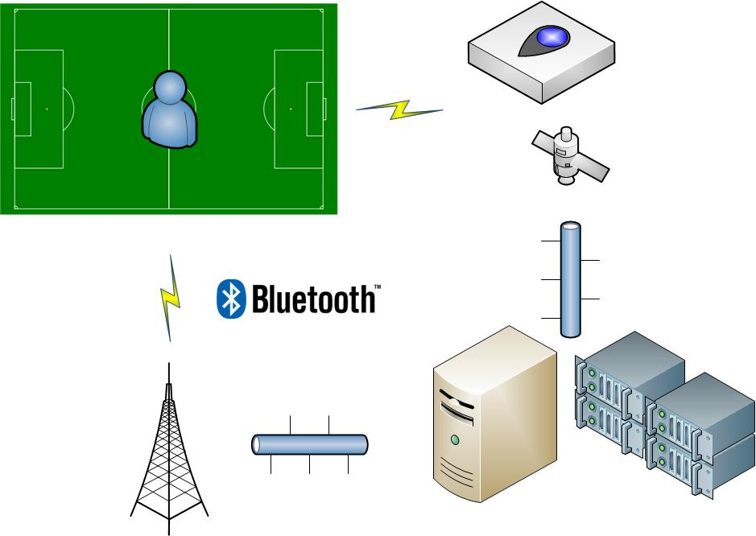
Figure 2: A hypothetical schematic for NAISTS

Design Rationale
The GUI interface is shown in Figure 3 and 4. There are two windows related to the program: The control panel and the soccer field display.
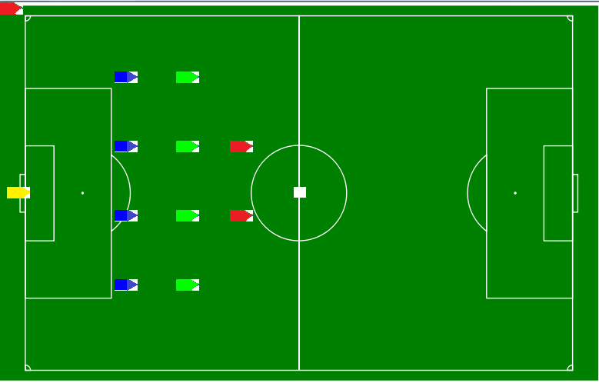
Figure 3: The soccer field display window

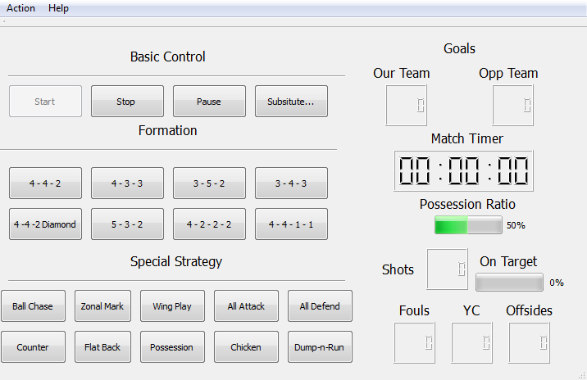
Figure 4: The NAISTS Control Panel
The soccer field display is supposed to obtain real time position information from the input module, and display the location of the ball and the player as such. The color of the player indicate their roles: red are attackers, green are midfielders, blue are defenders, yellow is the goalkeeper.
The control panel is where the coach can assign formation, choosing strategy and make substitution of players in the system. The control panel also features basic match information such as timer, goals on each team, possession ratio, shots and on target ratio, number of fouls, yellow cards and offsides. This is also where you would adjust settings for your I/O module hardware.
Note that we do not put opposition location on to the field. Since NAISTS is design to train only one team in a match, and we do not expect the opposition to wear any of the NAISTS-related devices, the opposition position is ignored.

3.2.1 Formations and Strategies
In this section we will briefly introduce starting formation and strategies of soccer included in NAISTS, for those who are not familiar with the sport. [14]
Starting formations
The formation describes how the players in a team are positioned on the pitch. Different formations can be used depending on whether a team wishes to play more attacking or defensive football. Formations are described by categorizing the players (not including the goalkeeper) according to their positioning along (not across) the pitch, with the more defensive players given first. For example, 4-4-2 means four defenders, four midfielders, and two forwards. Figure 4 shows the graphical representation of all the formations listed.
4-4-2
This formation was the most common in football in the 1990s and early 2000s. The midfielders are required to work hard to support both the defense and the attack: typically one of the central midfielders is expected to go up-field as often as possible to support the forward pair, while the other will play a "holding role", shielding the defense; the two wide midfield players must move up the flanks to the goal line in attacks and yet also protect the fullback wide defenders.
4-3-3
The three midfielders normally play closely together to protect the defense, and move laterally across the field as a coordinated unit. The three forwards split across the field to spread the attack, and may be expected to mark the opposition full-backs as opposed to doubling back to assist their own full-backs, as do the wide midfielders in a 4–4–2. When used from the start of a game, this formation is widely regarded as encouraging expansive play, and should not be confused with the practice of modifying a 4–4–2 by bringing on an extra forward to replace a midfield player when behind in the latter stages of a game.
5-3-2
This formation has three central defenders (possibly with one acting as a sweeper.) This system is heavily reliant on the wing-backs providing width for the team. The two wide full-backs act as wing-backs. It is their job to work their flank along the full length of the pitch, supporting both the defense and the attack.
3-5-2
This formation is similar to 5–3–2 except that the two wingmen are oriented more towards the attack. Because of this, the central midfielder tends to remain further back in order to help prevent counter-attacks.
3-4-3
Using a 3–4–3, the midfielders are expected to split their time between attacking and defending. Having only three dedicated defenders means that if the opposing team breaks through the midfield, they will have a greater chance to score than with a more conventional defensive configuration, such as 4–5–1 or 4–4–2. However, the three forwards allow for a greater concentration on attack. This formation is used by more offensive-minded teams.
4-4-2 Diamond
The 4–4–2 diamond (also described as 4–1–2–1–2) staggers the midfield. The width in the team has to come from the full-backs pushing forward. The defensive midfielder is sometimes used as a deep lying playmaker.
4-2-2-2
Often referred to as the "Magic Rectangle", it is a strategy that represents of a style Chilean, French and Colombian. This formation requires a particularly alert and mobile front four to work successfully.

4-4-1-1
A variation of 4–4–2 with one of the strikers playing "in the hole", or as a "second striker", slightly behind their partner. The second striker is generally a more creative player, the playmaker, who can drop into midfield to pick up the ball before running with it or passing to teammates.
Common Strategies
Ball Chasing
Ball chasing implies just that: Everyone going for the ball, leaving majority of the opponent player unmarked. This is the most primitive form of strategy, it can effectively restrict the passing path of the opponent ball carrier, but will leave defense in a very vulnerable position.
Zonal Marking
Zonal Marking is a defensive strategy where defenders cover an area of the pitch rather than marking a specific opponent. If an opponent moves into the area a defender is covering, the defender marks the opponent. If the opponent leaves this area, then marking the opponent becomes the responsibility of another defender.
Wing Play
Wing Play relies on the left/right wingers – namely the people closest to the side of the field, to deliver the ball from the back to the front. They will attempt to cross the ball to the center-forward attacker who will be waiting inside the opponent penalty box.
All attack / All defend
All-attack is where everyone on the team, except the goal keeper and may be one defender, is staying at their own half. Of the field All-defend is the exact opposite – everyone is at their own half except one striker up front. All-attack are usually in situation where the team is trailing and time is very limited, where All-defend are used when the team is winning and they are trying to protect their lead in the time remaining.
Counter-attack
Counter-attack is a strategy where the team lures the opponent into attack by staying in the back and slows down the pace, but once in possession of the ball, the entire team move uniformly towards the front in quick pace, in order to catch the opponent defender “napping”. That is because when the opponent gives away possession in midfield or attack, their defenders will tend to be further up the field than usual and may not be able to quickly adjust to a defensive mindset. This strategy is very exhausting for the attacking side, so it is not feasible to be constantly in use throughout the match.
Flat-back
The flat-back, also known as the offside trap if the offside rule is enforced, is a defensive tactic designed to "trap" the attacking team into an offside position. When an attacking player is making a run up the field with a team-mate ready to kick the ball up to him, all the defenders (except one, almost invariably the goalkeeper) will move up-field in order to put the attacker behind them just before the ball is kicked, hence putting the attacker in an offside position at the moment when the ball is kicked. The tactic requires good timing by the defense. If the offside trap fails, the attacking player will have an almost clear run towards the goal.
Possession
Teams that aim to retain control of the ball over longer periods of time, in the process making a large percentage of passes that give low risk of losing the ball, are said to be playing possession football. Utilizing this tactic demands players skillful in ball control and precise passing. If successful, it will tire opposing players because they have to run and tackle more.
Chicken
This is a demo mode specifically for NAISTS to test its I/O modules and does not reflect any commonly used strategy. The chicken mode is instructing the players to move randomly.
Dump-n-run
A commonly used time-wasting tactic, the player who gain the possession of the ball will try to kick the ball as hard as he can down the field and just go out of bounds, shaving precious time to the opponent as they will need to go back to their own half and release the ball by throw-in.

Algorithm and Implementation
In this section we will look at algorithm that was implemented in some of the strategies.
Environment
The field is configured to be displayed in full screen at 800x400 resolutions, and scale accordingly for computer monitors that using other resolution. Each players occupy a 4x2 cluster, while the ball is 2x2. In the demo version of NAISTS, the player can turn at an angle that is divisible by 30 degrees. The friendly team attacks to the right of the field.
Ball Chasing
In ball chasing mode, the field is separate into three major parts (see figure 6). Defender holds the left third, Midfielders hold the middle third, and Attackers located at the right third. When the ball arrives in a specific zone, the respective players will be chasing the ball.
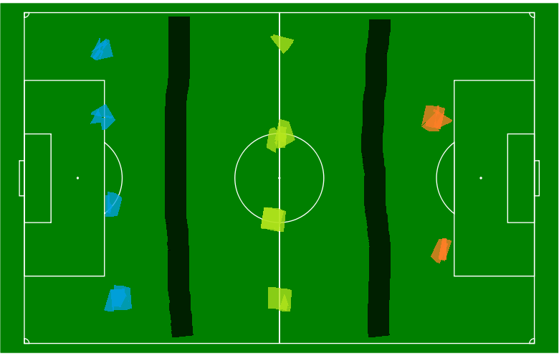
Figure 6: The Zone partition of the Ball chasing algorithm

The algorithm will receive the location of the ball via the NAISTS input module. Once the location is determined, it will issue commands to the player in the respective zone to turn their head and go towards the ball.

Wing Play
Once the team gain possession of the ball, the algorithm will call its team player to send the ball to either the left or the right wing midfielder or defender, depends on the starting formation. The ball carrier will run up from the sidelines, and the attacker will also follow their move in preparation of receiving the cross. See figure 7 and 8 below.
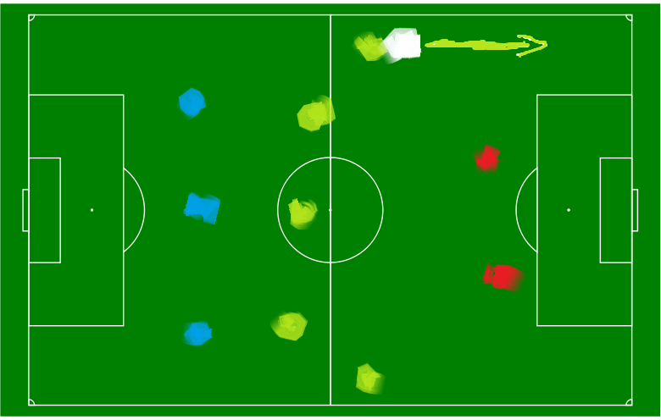
Figure 7: The left-winger has the ball, and running upfield close to the sideline (towards the right of the screen)
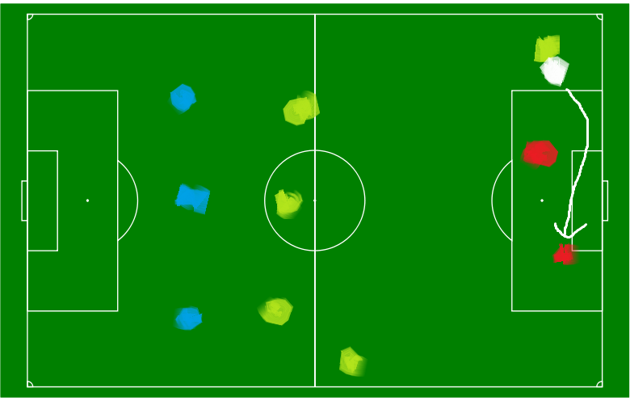
Figure 8: The ball is passed from the LW to the attacker at the far post.

Knowledge Base

In all strategies included in NAISTS with the exception of ball chasing and chicken, each player will have statistics that is constantly being modified in the match. These statistics include ball possession, shots and on target ratio and time spent out-of-assigned-position. Other statistics, like fouls, yellow cards and other rule infraction, will need to be entered manually from the control panel when the infraction occurs. Having a KB will allow the algorithms above to make better decision on what the player should do, and who will have a higher chance to score a goal, based on background logic provided by the KB and the inference logic inside the algorithm.

Simulation
Since there is no available hardware as of this point to support the input and output modules, we have modified the input and output for the demo.
For the NAISTS control panel, we host it in a PC server inside our college infrastructure, powered by two Intel Xeon E5504 quad-core CPU with 20 GB of physical RAM.
For the input, we have the movement of the ball at random, with 60% of the moves are heading toward the friendly team’s goal, until it was being “possessed” by a team mate. When the teammate has the ball, he has a 90% chance of retaining possession if his next 2 steps are on a straight line, and 75% chance of retaining possession if he changes direction. This is to simulate the ball carrier being tackled by an opponent. When the ball is free again, it will move at random with the criteria above.
For the output, we have utilized an on-campus SMTP server, and sending short SMS messages to three volunteer’s cell phone. This is done by sending email to the user’s phone company SMS gateway. A SMS gateway is a telecommunications network facility for sending or receiving Short Message Service (SMS) transmissions to or from a telecommunications network that supports SMS.
In order not to overwhelm user with text messages and potential fees that come with it, we have set the demo to send out a message every 30 seconds with the demo last only 5 minutes. Also, all messages are being logged to a text file that resides with the server where NAISTS control panel is running. Figure 8 and 9 shows a screenshot of user’s phone and an excerpt of the log file. Note that a portion of the screenshot is obscured because that contains part of the volunteer’s cell phone number and it is removed for privacy reasons.
Figure 9 shows the text message from one of the volunteer’s phone received and Figure 10 shows the log file from a demo. In the log file, the first section is the match setup, the “F:” and the “S:” indicates formation and strategy used here. The numbers on the setup section indicates the destination email/SMS address for that player shirt number, which is redacted here. The section below the “MATCH START” entry contains the log of the control panel usage, along with what message is being sent to each player. Note that it sends out message to users every 30 seconds, with the exception of special messages such as if one of the team member scores a goal, a special message is sent to all players on the team, with a special message sent to the goal scorer.

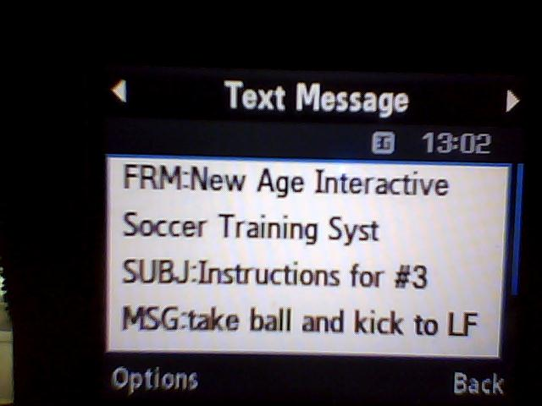
Figure 9: A sample SMS message received by one of the volunteers during the demo
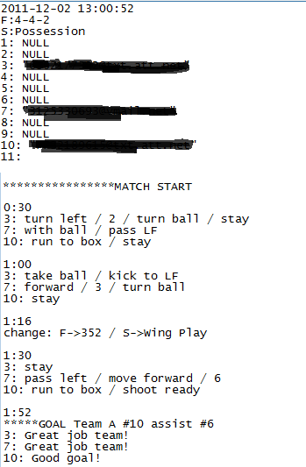
Figure 10. A sample log file from the same demo

DISCUSSION
In this section we will discuss some of the software design issue, as well as potential cost of building the entire system.
4.1 Software design
The GUI is created and compiled by Nokia Qt Creator, which is designed for portability across different operating system such as Linux. However due to the constraint posted by the non-commercial nature of the compiler, we were unable to combine the field display and the control panel into one window, as the user interface does not support embedding of PNG images. All image file needs to be drawn at a separate window.
As the extension of the above issue, we cannot use drag-and-drop functionality over the objects in the image, such as the players on the field. To go around it, we use the solution button on the control panel. A pop-up window will show, allow you to enter the new player’s name and number, along with its initial position.
The knowledge base is stored in a 2-dimensional array in the main memory of the machine where the control panel is running on. As the match goes on, the “lag” effect starts to show up on pitch movements as well as responsiveness of the control panel. In our server for example, the control panel was unresponsive after approximately 40 minutes of continuous use. One way to solve this is to set a point where all the information stored in memory will be “dumped” to the local storage (a hard drive) and remove a certain percentage of data, preferably from the oldest. We cannot delete the entire KB at once, as the algorithm will need some sort of prior knowledge in order to be working efficiently and correctly.
4.2 Hardware in the I/O modules
Currently there are no similar system exists, at least in the context of sports. In this section we will discuss what kind of hardware or equipment are needed, potential modification, and estimated cost.
The Input Module
In order for NAISTS to work correctly, two pieces of information is needed for each player: their location, and the direction their face is looking at the moment. To obtain these two information, we rely on two different technologies: Global Position System and Charge-Coupled Device (CCD).
Global Positioning System (GPS)
GPS is a space-based satellite navigation system that provides location and time information in all weather, anywhere on or near the Earth, where there is an unobstructed line of sight to four or more satellites.
One way to acquire player’s location will be requiring every team member to wear a GPS receiver watch on the field. Such watches, such as the GlobalSat GH-625M GPS Sports Watch, are commercially available and very popular among track runners and hikers. [15] A third-party open source software called “gh615” [16] replaces the manufacture’s original software and includes a lot more information such as waypoints and device information. We can modify this software to suit the input requirement of NAISTS. The watch has a manufacturer suggested retail price (MSRP) of $120.
The current resolution of GPS is about 2-3 meters (6-9 ft.), and in the worst case about 7.8 meters (22 – 25 ft.). [17] In most case, the resolution is fine enough for on field use.
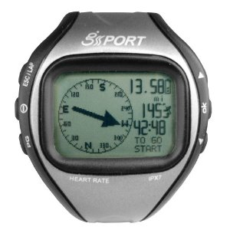
Figure 11. GlobalSat GH-625M Sports Watch

Charge-Coupled Device (CCD) / On-field camcorder
GPS only allows the determination of location of the field, but it does not determine the direction in which you are facing. This is where CCD comes in to play.
The CCD is an electric light sensor that is used in all digital cameras. Our proposed solution is to have each person to wear a light-reflective triangular device, yet it is not intrusive to wear on the field. One solution is to wear a triangular-shaped tinfoil hat.

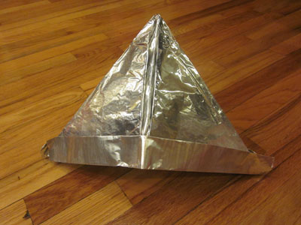
Figure 12. A triangular tinfoil hat

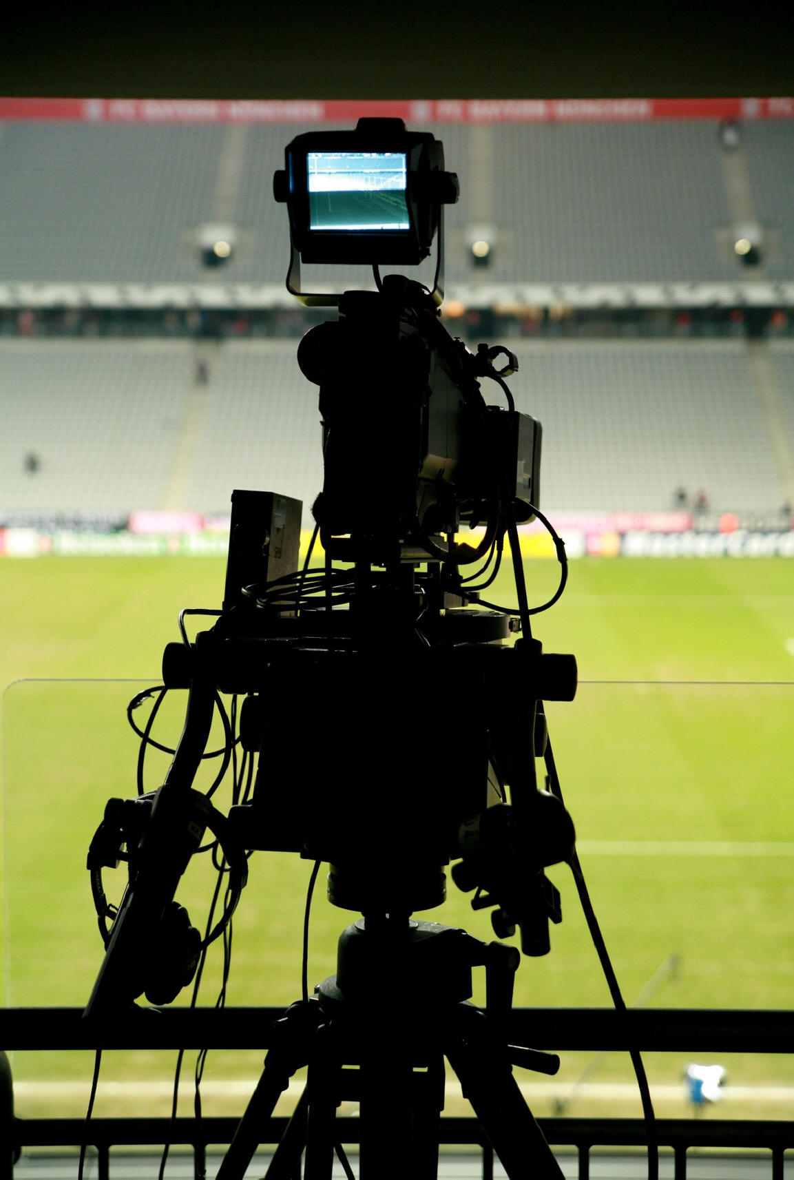
Figure 13. An onfield camcorder
A camcorder captures the images of players and feed it real time to a digital imaging processing system, where the tinfoil hats are identified, and feed back to NAISTS. A camcorder such as the highly-regarded Panasonic Pro AG-DVC20 3CCD, cost about $3,000 each [18], and to properly cover the field you will need eight of them: three on each of the long edges of the field, and one behind each of the goal posts.
The output module
Messages that come out of NAISTS will first need to be translated to speech via a text-to-speech module, and transmit to player’s earpiece via Bluetooth.
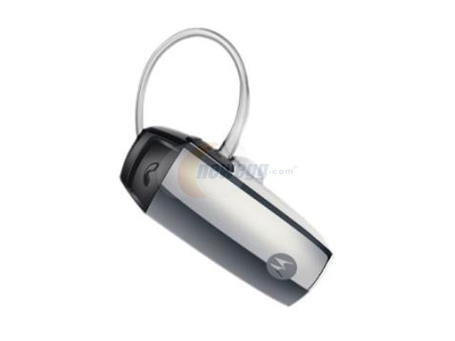
Figure 14. A Bluetooth earpiece

The field needs to be outfitted with Class-1 Bluetooth transmitter. According to the specs [19], Class-1 can transmit up to 100-meter range, so at most, six transmitters are enough to cover the whole field. Transmitter and earpiece cost approximately $30 each. ([20],[21]).

CONCLUSION
We present a novel interactive soccer training system where children can learn teamwork, team spirit, valuable decision making and social skills. We have mentioned important points about promoting physical and emotional health. We have described the design criteria, design rationale (including formation and strategies). We also mentioned the problems that occurred during the demo, including software bugs and logic issues.
The obvious problem in testing the effectiveness of NAISTS is because we do not have real input and a real test population, because doing such will not only require the appropriate, and often expensive equipment, but also manpower to perform modification to the software and hardware, as well as manpower to maintain such equipment, such as security.
As future work, we intend to redesign the NAISTS processing module in a way that it will require the least amount of effort possible from hardware modification. More efficient algorithm is also called for to prevent “lag” and unresponsiveness due to memory issues. A GPS watch with a compass may eliminate the need of using expensive camcorders altogether since it provides a directional component, but modification to the manufacturer software is needed to extract such data. A potential port to a different design/coding platform might help solve some of the GUI issues that we encountered.

ACKNOWLEDGEMENTS
The author thanks Anne Celestino, James Jilek and Ernesto Reyna from UIC College of Education, for volunteered during the demo of NAISTS and provide important feedback. Special thanks to UIC Computer Science Professor, Dr. Tom Moher for helpful discussions during the initial phase of the conception of NAISTS.

REFERENCES
- Physical milestones. (2003). Scholastic Parent & Child Magazine, 10(6), 40.
- Nonis, K. (2005). Kindergarten teachers' views about the importance of preschoolers' participation in sports in Singapore, Early Child Development & Care, 175, 719-742.
- Yan, J., & McCullagh, P. (2004). Cultural influence on youth's motivation of participation in physical activity. Journal of Sport Behavior, 27, 378-390..
- Piko, B., & Keresztes, N. (2006). Physical activity, psychosocial health, and life goals among youth. Journal of Community Health, 31, 136-145.
- http://www.letsmove.gov/learn-facts/epidemic-childhood-obesity
- Harrison, P., & Naraya, G. (2003). Differences in behavior, psychological factors, and environmental factors associated
- with participation in school sports and other activities in adolescence. Journal of School Health, 73, 113.
- Wikipedia, 2011, Soccer in the United States. http://en.wikipedia.org/wiki/Soccer_in_the_United_States
- Wikipedia, 2011, 2012 Phenomenon. http://en.wikipedia.org/wiki/2012_phenomenon
- Blom, Lindsey & Blom, Tim (2009). Survival Guide for Coaching Youth Soccer, 102-103
- CyberSports product page, 2011. CyberSports Ltd. http://cybersportsworld.com/page/3/products.htm
- Football Superstars forum, 2011.CyberSports Ltd. http://bit.ly/uW7kke
- Football Superstars forum, 2011. CyberSports Ltd. http://bit.ly/ue3reP
- Football Superstars forum, 2011. CyberSports Ltd. http://bit.ly/uejXEH
- BBC Sport, 2011. Formations Guide. British Broadcasting Corporation http://news.bbc.co.uk/sport2/hi/football/rules_and_equipment/4197420.stm
- http://www.amazon.com/GlobalSat-GH-625M-GPS-Sports-Watch/dp/B001TLEXRA
- http://code.google.com/p/gh615/

- GPS Accuracy, 2011. National Coordination Office for Space-Based Positioning, Navigation, and Timing
http://www.gps.gov/systems/gps/performance/accuracy/
- http://www.amazon.com/Panasonic-AG-DVC20-Proline-Camcorder-Optical/dp/B000DZH7NA/ref=sr_1_1
- Wikipedia,2011. Bluetooth. http://en.wikipedia.org/wiki/Bluetooth
- http://www.nrebate.com/en/bluetooth-class-1-usb-20-dongle-100-meter-range.html?language=en&currency=USD
- http://www.amazon.com/Motorola-H500-Bluetooth-Headset-Nickel/dp/B0006HTZ80/ref=sr_1_26?ie=UTF8&qid=1323462808&sr=8-26

